Action event proposal

Complete this proposal, making sure you meet the requirements in the brief. These requirements are repeated on page 2 of this document.

Action Event
When: | Every 9th August | Where: | Greenhithe park
Action: | Hug someone  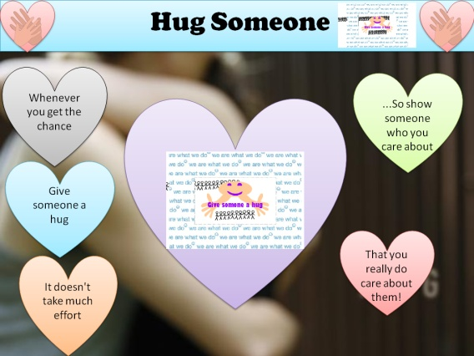 | Reasons for choice: | I chose this action, because this simple deed helps people a great deal, both mentally, and physically. Through a hug, a person’s attitude towards others changes. They become more positive and also want help others more and are generally in a much better mood. Also scientists say, that giving and receiving hugs reduces the blood pressure in your body. It raises the happy chemical Oxytocin, which reduces the risk of you getting heart disease. So Hugging improves your Health !
 | Key features |  |  | Teacher feedback
Logo | This will be made in macromedia Flash but most of the artwork will be made in fireworks. It will be, basically a head and a pair of, hugging arms (which were used in the discovery board) inside the fixed border which was supplied in the SPB. Which drop from the top of the screen, then the action name will rise into the hands. At this point rows of stick men holding hands will zip across the top and bottom of the logo screen. The logo then loops and the animation start again.
 | Target Audience | Key features |  | Teacher feedback
Digital Poster | 10 -above | This will be made using PowerPoint, It consists mainly of two heart symbols with two hands in the centre as a mini logos,(these drop from the top of the screen into the fixed border at the top section of the page. Then a larger Heart rises from the base bearing the logo and at the sides comments in smaller hearts pop into the page with promotional text.
Discovery Board | 12-above | This Board Will be made multimedia flash; It would include many pictures of hugs and reasons why it can help. Also an animation of what the effects of a hug on a person would be, it would be a simple video for fairly young people, it should have around 5 or 6 hotspots
Podcast | 8-above | This would be made to appeal to the younger audience, as you don’t really need to be very old to do this action, and So would include a person hugging someone, and then seeing how they act through the rest of the day, it will be less than a minute long, and made using windows media. My logo will be included
Web page | 11-above | This will promote my action, giving people fun ideas on who to hug or how show some sign of friendship and love to. It will include my logo as well.

Requirements

Action - Which action will you focus on? You may pick any appropriate action supported by We Are What We Do. You may select ‘Add your own action' which means that you can focus on an appropriate idea of your own. Check with your teacher.

When - The action event can take place any time you like.

Where - You are trying to reach as wide an audience as possible. You may choose any public place such as the town park, market square or leisure centre. You must not hold the event at your centre.

Logo - You must produce a simple animation to complete a logo for the Action Event, to be used on all products. The animation needs to be relevant to your chosen action. What do you think it will be like?

Products - Outline your ideas for each of the products

